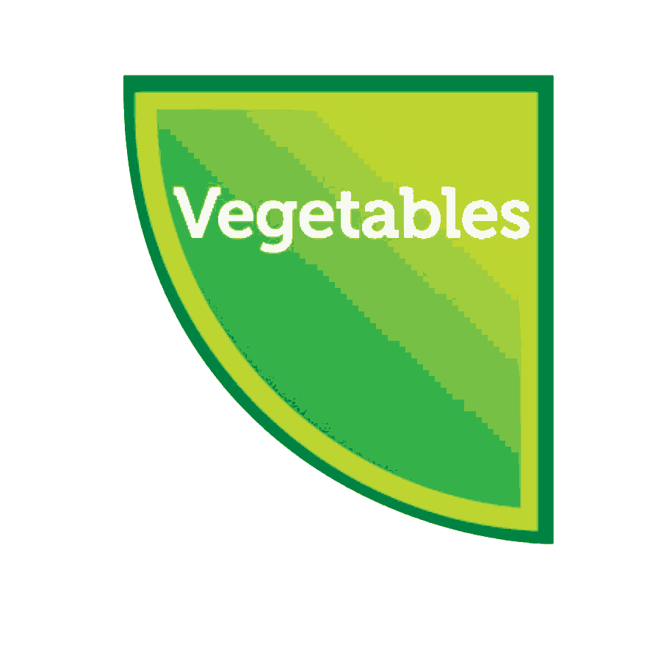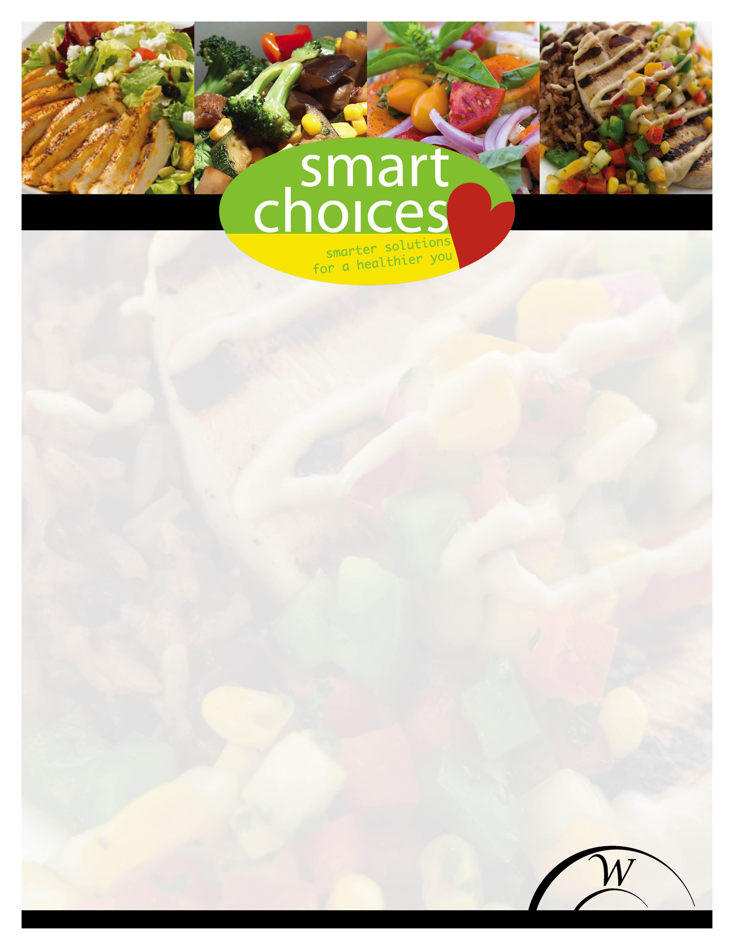

**Our Smart Choices theme this month is vegetarian awareness. Even if you are not a vegetarian family, try eating one veggie based meal daily to reap the benefits of a diet rich in plant proteins. Have your students come to the Café and give this a try! Delicious!**

**This meal meets USDA standards for fruit, grain, dairy and protein requirements.**

**Smart Choices menu pic for April 26th**

***Veggie Tostada***

Spicy refried beans topped with fresh lettuce, Pico de Gallo and avocado, all piled on a baked, whole grain tortilla.

Students $3.25

Adults $4.50